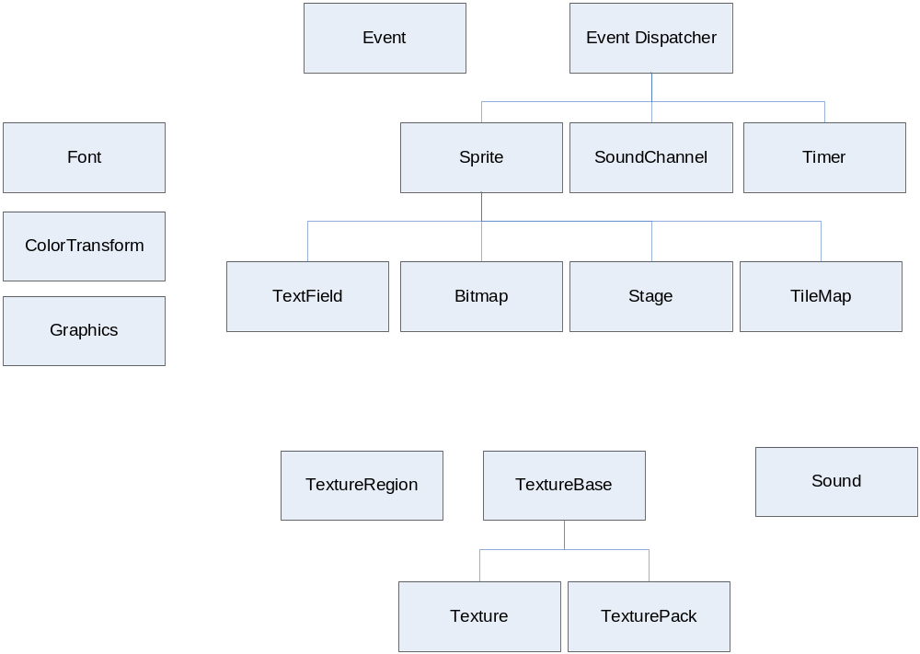
EventDispatcher
EventDispatcher.new() → EventDispatcher
EventDispatcher:addEventListener(string type, function listener, [data])
EventDispatcher:removeEventListener(string type, function listener, [data])
EventDispatcher:dispatchEvent(Event event)
EventDispatcher:hasEventListener(string type, function listener, [data]) → bool

Global Events
Event.ENTER_FRAME = “enterFrame”

Event
Event.new(string type) → Event

Sprite → EventDispatcher
Sprite.new() → Sprite
Sprite::addChild(Sprite child)
Sprite:removeChild(Sprite child)
Sprite:removeChildAt(int pos)
Sprite:getNumChildren()
Sprite:getChildAt(int pos)
Sprite:getParent(int pos)
Sprite:contains(Sprite child)
Sprite:getX()
Sprite:getY()
Sprite:getRotation()
Sprite:getScaleX()
Sprite:getScaleY()
Sprite:setX(number x)
Sprite:setY(number y)
Sprite:setRotation(number rotation)
Sprite:setScaleX(number sx)
Sprite:setScaleY(number sy)
Sprite:localToGlobal(number x, number y) → x, y
Sprite:globalToLocal(number x, number y) → x, y
Sprite:isVisible()
Sprite:setVisible(bool visible)
Sprite:getColorTransform() → ColorTransform
Sprite:setColorTransform(ColorTransform colorTransform)
Sprite:hitTestPoint(number x, number y) → bool
Sprite:getWidth()
Sprite:getHeight()
Sprite:getMatrix() → Matrix
Sprite:setMatrix(Matrix m)
Sprite:getAlpha()
Sprite:setAlpha(number alpha)
Sprite:getBounds() → x, y, width, height
Sprite:setBlendFunc(string blend)
Sprite:clearBlendFunc()

Sprite Events
Event.ADDED_TO_STAGE = “addedToStage”
Event.REMOVED_FROM_STAGE = “removedFromStage”
Event.MOUSE_DOWN = “mouseDown”
Event.MOUSE_MOVE = “mouseMove”
Event.MOUSE_UP = “mouseUp”
Event.TOUCHES_BEGIN = “touchesBegin”
Event.TOUCHES_MOVE = “touchesMove”
Event.TOUCHES_END = “touchesEnd”
Event.TOUCHES_CANCEL = “touchesCancel”

TextureBase
TextureBase:getWidth()
TextureBase:getHeight()

Texture → TextureBase
Texture.new(string filename) → Texture

TexturePack → TextureBase
TexturePack.new(string txtfile, string imagefile) → TexturePack
TexturePack.new(table filenames) → TexturePack
TexturePack:getTextureRegion(string filename) → TextureRegion

TextureRegion
TextureRegion.new(Texture texture) → TextureRegion
TextureRegion.new(Texture texture, x, y, width, height, [dx1, dy1, dx2, dy2]) → TextureRegion

Bitmap → Sprite
Bitmap.new(Texture texture) → Bitmap

Font
Font.new(string txtfile, string imagefile) → Font

TextField → Sprite
TextField.new(Font font, string text) → TextField
TextField:getText()
TextField:setText(string text)
TextField:getTextColor() -> int
TextField:setTextColor(int color)
TextField:getLetterSpacing()
TextField:setLetterSpacing(number spacing)

Timer → EventDispatcher
Timer.new(number delay, int repeatCount) → Timer
Timer:start()
Timer:stop()
Timer:reset()
Timer:getDelay()
Timer:getCurrentCount()
Timer:getRepeatCount()
Timer:getRunning()
Timer:setDelay(number delay)
Timer:setRepeatCount(int repeatCount)
Timer.pauseAllTimers()
Timer.resumeAllTimers()

Timer Events
Event.TIMER = “timer”
Event.TIMER_COMPLETE = “timerComplete”

Sound
Sound.new(string filename) → Sound
Sound:play(number startTime, int loops) → SoundChannel
Sound:getLength()

SoundChannel → EventDispatcher
SoundChannel:getPosition()
SoundChannel:stop()

SoundChannel Events
Event.SOUND_COMPLETE = “soundComplete”

